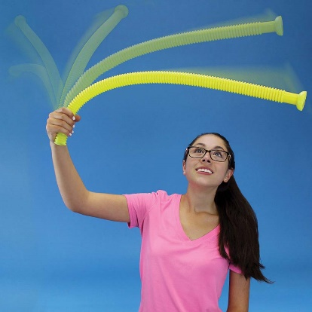
Whirly Tube Investigation

Background
A whirly tube – also known as a sound hose, corrugaphone, or bloogle resonator (and no, I did not just make that one up) – is a corrugated plastic tube that produces sounds of various pitches as it is swung around at different speeds. Though the movement of the air inside it is highly complicated (mostly due to the corrugations, without which no sound would be produced), the whirly tube essentially functions as an open-ended pipe.

Aim
To experimentally determine the fundamental frequency of a whirly tube.

Equipment
- Your device, with Audacity (www.audacityteam.org) installed
- A whirly tube
- A metre ruler
- A thermometer

Method
Your method should clearly describe the steps you will follow and any calculations you will perform.

Discussion
- Use your results to determine the fundamental frequency of the whirly tube.
- Estimate the speed of sound using the air temperature of the room (T) and the formula:
$$v=331\sqrt{1+\frac{T}{273}}$$

Use this velocity and the length of the whirly tube to calculate an expected value for the tube’s fundamental frequency. Compare your expected value to your observed value (from Q1) and present a reasonable explanation for any differences.
- Swing the whirly tube around with the end you are holding blocked off. What do you observe, and what does this tell you about the movement of air inside the tube?
- Identify one source of error in your experiment. How would you expect this to affect your results?
- Identify one possible improvement to your experiment. Your improvement must not require equipment that you do not have access to.

